# Integrating Community-Based Health Promation & Primary Care to Improve Diabetes Self-Management

Diabetes is a growing problem in Kentucky with approximately 13.6% of adults diagnosed, ~101,000 people with diabetes that are not diagnosed and ~33.8% of adults with prediabetes [1]. However, individuals with chronic conditions lack the skills, resource’s and capacity needed to properly manage their disease on their own [2]–[4]. Evidence from many large trials have demonstrated that integrating community-based health promotion programs and primary care will lead to improved health outcomes and reduced costs [5]. Recently, Costa Rica has been recognized as an example success story for its implementation of Integrative Health (i.e., combining public health and primary care into a single community-based delivery model) [6]–[10]. The 5 key lessons learned over the past 5 decades are 1. Integration of public health with primary health care, 2. Multidisciplinary teams integrated within the community, 3. Geographic empanelment, 4. Measurement and quality improvement at all levels, 5. Integration of digital technologies at all levels. An important side-effect of this approach is that many older people “age-in-place” [11], [12] thus reducing the need for long-term care facilities. Additionally, this preventive care, at all levels, approach substantially reduces ER use for non-emergency services. Luca Cuccia, et. Al. quantify Costa Rica’s accomplishments in terms of evidence-based metrics which has recently gained the attention of healthcare organizations in the United States and other countries [9].

Federally Qualified Healthcare Centers (FQHC) and Rural Health Clinics (RHC) take an important step toward integrating public health and primary care. However, the Costa Rician Healthcare System better leverages multidisciplinary teams integrated within the community to insure better care coordination across public health functions, primary, secondary, and tertiary care. Thus, leading to improved scalability of preventive care services. The study hypothesis that by reorganizing community health workers, kynectors and other roles into a model similar to the Costa Rician EBAIS teams and improving coordination with FQHC and RHC will lead to an overall improvement in quality of care, outcomes, and costs. Additionally, evidence-based health promotion programs (EBP) can be introduced into the community-based team to improve self-care. Targeted EBP programs for diabetes could be introduced that follow a similar process to [13].

This study proposes a longitudinal approach that investigates the quality-of-care relative to disease progression and the impact of individual community-based components such as FQHC/RHC and community-based teams. The study will also compare and contrast the current model of care to that of the Costa Rician community-based model in order to extract evidence-based programs that can be tested in Kentucky. This approach will allow not only the comparison of community-based care vs traditional primary care outcomes but can also examine factors that drive disease complications and progression in both settings.

This can be compared to the Costa Rician approach to extract best practices that show the strongest evidence of effectiveness. From this investigation, recommendations can be proposed that bring in best practices from local experiences and the Costa Rician model of healthcare delivery.

## Aims:

### Develop compliance & outcomes measurement framework (or utilize variation on existing framework such as HEDIS).

### Develop analysis models utilizing survival analysis and other appropriate techniques.

### Identify high-value EBP targets and regions for field pilot projects.

### Develop EBP pilot testing protocol to collect verification data in the field.

### Analyze pilot results and provide policy & clinical practice guideline recommendations.

## Target Research Areas:

### Mental health EBP’s (e.g., depression, anxiety, chronic stress, addiction, etc.).

### Social health EBP’s (e.g., isolation, social support, peer-support, etc.).

### Healthcare Quality & Access EBP’s (e.g., community clinics, community-based teams).

### Technology enabled EBP’s (e.g., telehealth, mobile screening, etc.).

### Community & Clinical Education EBP’s (e.g., self-care, …).

## Benefits:

### Quantitatively highlight the value of prevention over institutional disease management to reduce long-term costs and improve population health.

### Identify the key components and processes that support the most effective delivery system.

### Analysis models could be integrated into technology reimbursement and payment systems. Additionally, could be employed to measure provider quality of care.

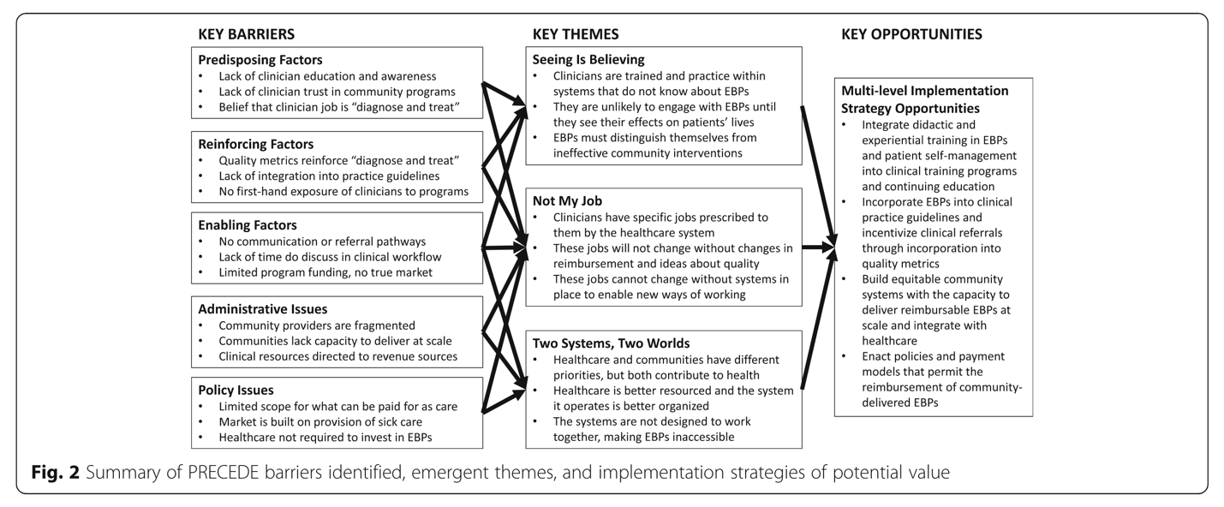

# Rural Health Outreach

“Community health workers, kynectors, and other job roles are a relatively new addition to the array of public health and government services available to Kentuckians. There is academic evidence that people with local knowledge and cultural credibility are particularly well-positioned to engage with communities and help them access services like kynect or health department services. There is less known that directly relates to the needs of rural communities and other underserved parts of a state like Kentucky. Could a research team help CHFS quantify the benefits of these roles?” How are CHW and kynectors teams organized in Kentucky.

# FQHC/RHC

Federally Qualified Health Care Centers and Rural Health Clinics are reimbursed differently than other provider types. What is the health status of Medicaid members who are treated by FQHCs and RHCs vs traditional primary care providers? Are FQHC and RCH facilities providing services as outlined in their respective regulations? Are individuals with diabetes better served at an FQHC?

**References:**

[1] “ADV_2021_State_Fact_sheets_Kentucky.pdf.” Accessed: Jul. 05, 2022. [Online]. Available: https://diabetes.org/sites/default/files/2021-10/ADV_2021_State_Fact_sheets_Kentucky.pdf

[2] P. J. Cunningham, “Chronic burdens: the persistently high out-of-pocket health care expenses faced by many Americans with chronic conditions,” *Issue Brief Commonw. Fund*, vol. 63, pp. 1–14, Jul. 2009.

[3] M. P. Gallant, “The influence of social support on chronic illness self-management: a review and directions for research,” *Health Educ. Behav. Off. Publ. Soc. Public Health Educ.*, vol. 30, no. 2, pp. 170–195, Apr. 2003, doi: 10.1177/1090198102251030.

[4] K. Gallacher, C. R. May, V. M. Montori, and F. S. Mair, “Understanding patients’ experiences of treatment burden in chronic heart failure using normalization process theory,” *Ann. Fam. Med.*, vol. 9, no. 3, pp. 235–243, Jun. 2011, doi: 10.1370/afm.1249.

[5] A. L. Leppin *et al.*, “Integrating community-based health promotion programs and primary care: a mixed methods analysis of feasibility,” *BMC Health Serv. Res.*, vol. 18, no. 1, p. 72, Dec. 2018, doi: 10.1186/s12913-018-2866-7.

[6] M. Pesec, H. Ratcliffe, and A. Bitton, “BUILDING A THRIVING PRIMARY HEALTH CARE SYSTEM: THE STORY OF COSTA RICA,” p. 82.

[7] “What Does Community-Oriented Primary Health Care Look Like? Lessons from Costa Rica,” Mar. 16, 2021. https://www.commonwealthfund.org/publications/case-study/2021/mar/community-oriented-primary-care-lessons-costa-rica (accessed Apr. 01, 2022).

[8] M. Pesec, H. L. Ratcliffe, A. Karlage, L. R. Hirschhorn, A. Gawande, and A. Bitton, “Primary Health Care That Works: The Costa Rican Experience,” *Health Aff. (Millwood)*, vol. 36, no. 3, pp. 531–538, Mar. 2017, doi: 10.1377/hlthaff.2016.1319.

[9] L. Cuccia, J. Chadwick, A. Kim, R. Sivarajan, and V. Wong, “Costa Rica’s Health Care Reform: Impact and Success of the EBAIS Model,” p. 12.

[10] T. R. Sullivan, “A Comparison of the United States and Costa Rican Health Care Systems and Their Influence on Immigrant Women’s Maternal and Child Health Outcomes,” p. 33.

[11] “Aging in Place: Growing Older at Home,” *National Institute on Aging*. https://www.nia.nih.gov/health/aging-place-growing-older-home (accessed Jul. 05, 2022).

[12] “Overview of Aging in Place – RHIhub Aging in Place Toolkit.” https://www.ruralhealthinfo.org/toolkits/aging/1/overview (accessed Jul. 05, 2022).

[13] D. D. Inman, K. M. van Bakergem, A. C. LaRosa, and D. R. Garr, “Evidence-Based Health Promotion Programs for Schools and Communities,” *Am. J. Prev. Med.*, vol. 40, no. 2, pp. 207–219, Feb. 2011, doi: 10.1016/j.amepre.2010.10.031.